Project Report

By

Benjamin Larsen

Darien Thomas

Peter Keres

Robin Geven

# **Table of Contents**

Table of Contents Page 1

1 Requirements / User Stories. Pages 2-10

2 Design Documentation. Page 11

3 Management Plan. Pages 12-18

4 Tests Pages 19-21

5 Version Control Pages 22-26

6 Screenshots Pages 27-30

7 What is Left Page 31

# **1** **Requirements / User Stories**

The user should be able to transfer money, view balance, and withdraw money.

An admin user should be able to create a card, and view atm machine status.

## **1.2** **User Stories**

### **1.2.1** **User Transfer**

Author: Team

Summary: A transfer system so that users can transfer money from one account to another.

Description: A user should be able to take an amount of money from an account and add it to another account. The amount taken from the account should not exceed the amount that is currently in the account. Also the user account the amount is being transferred too should be a valid account.

Total Planned: 3

Planned this cycle:

Total Actual: 3+

Actual this cycle:

Coder: Darian

Tester: Darian

Reviewer: Peter/ Robin

Status: development stage

Priority: High

### **1.2.2** **User view balance**

Author: Team

Summary: allows the user to view their account balance.

Description: A user should be able to view what their current balance is on there account. This would include any pending transactions that are currently tied to the user's account.

Total Planned: 2

Planned this cycle:

Total Actual: 2+

Actual this cycle:

Coder: Darian

Tester: Darian

Reviewer: Peter/ Robin

Status: development stage

Priority: High

### **1.2.3** **User withdraw**

Author: Team

Summary: allows the user to withdraw money from their account.

Description: the user should be allowed to withdraw any amount of money from there account. The amount of money that is withdrawn should not exceed the amount that is in the account. The amount withdrawn should then be reflected in the total amount for this account.

Total Planned: 3

Planned this cycle:

Total Actual:3+

Actual this cycle:

Coder: Darian

Tester: Darian

Reviewer: Peter/ Robin

Status: development stage

Priority: High

### **1.2.4 Extra User Pin Change**

Author: Team

Summary: allows the user to change the pin that is used on their account.

Description: The user should be able to update his pin on their account. The new pin should not be the same as the previous pin. The pin should not be more than 4 characters.

Total Planned: 4

Planned this cycle: NA

Total Actual: NA

Actual this cycle: NA

Coder:

Tester:

Reviewer:

Status: Planning Stage

Priority: Low

### **1.2.5 Extra User Change Phone Number**

Author: Team

Summary: allows the user to change the phone number that is used on their account.

Description: The user should be able to update the phone number on their account. The new phone number should not be the same as the previous pin. The number should follow the format of a standard phone number.

Total Planned: 4

Planned this cycle: NA

Total Actual: NA

Actual this cycle: NA

Coder: NA

Tester:NA

Reviewer:NA

Status: Planning Stage

Priority: Low

### **1.2.6 Extra User View Transaction History**

Author: Team

Summary: allows the user to view any transactions that are on their account

Description: the user should be able to view a list of transactions that happen in there account. On each transaction the user should be able to view the amount, date, and to what account the transaction went too. Also should be able to see the status of the transaction.

Total Planned: 6

Planned this cycle: NA

Total Actual: NA

Actual this cycle: NA

Coder: NA

Tester:NA

Reviewer:NA

Status: Planning Stage

Priority: Low

### **1.2.7 Admin Create Card**

Author: Team

Summary: an Admin should be able to create a new bank card

Description: an admin should be able to create a new bank card and tie it to a valid account in the system. While creating a bank card, the admin should be able to set the following fields. Pin, card number, data issued, expire date, address, balance, phone number, card status, and two factor status.

Total Planned: 8

Planned this cycle: 15

Total Actual: 7

Actual this cycle: 14

Coder: Ben / Peter

Tester: Ben

Reviewer: Peter / Ben

Status: Bug testing

Priority: High

### **1.2.8 Admin View ATM Status**

Author: Team

Summary: An admin should be able to view the status of an ATM

Description: an admin should be able to view the status of any ATM in the system. While viewing the status, the admin should be able to see the status, last refill date, and next refill date.

Total Planned: 5

Planned this cycle: 15

Total Actual: 6

Actual this cycle: 14

Coder: Ben

Tester: Ben

Reviewer: Peter / Ben

Status: Bug testing

Priority: High

### **1.2.9 Admin Create Accounts**

Author: Team

Summary: An admin should be able to create an account in the system.

Description: An admin should be able to create a user account. While creating the user account, the admin should be able to set the name, account number, and phone number. The account number should also be checked so it is unique. The phone number should follow the standard phone number format.

Total Planned: 3

Planned this cycle: 10

Total Actual: 4

Actual this cycle: 14

Coder: Ben / Peter

Tester: Ben

Reviewer: Peter / Ben

Status: Bug testing

Priority: High

### **1.2.10 Admin View Accounts**

Author: Team

Summary: An admin should be able to view an account on the system

Description: An admin should get a detailed view of any account on the system. This view should in include account name, account number, and phone number.

Total Planned: 3

Planned this cycle: 10

Total Actual: 3

Actual this cycle: 14

Coder: Ben / Peter

Tester: Ben

Reviewer: Peter / Ben

Status: Bug testing

Priority: High

**1.2.11 Extra Admin Reset Pin**

Author: Team

Summary: an admin should be able to reset a pin on an account

Description: an admin needs to have the ability to reset a pin on a valid account on the system. The pin should be less than 4 characters and should not be the same as the previous pin.

Total Planned: 4

Planned this cycle: 10

Total Actual: 4

Actual this cycle: 14

Coder: Ben / Peter

Tester: Ben

Reviewer: Peter

Status: Bug testing

Priority: Low

**1.2.12 Extra Admin Update expire date**

Author: Team

Summary: an admin needs to update the cards expire date

Description: an admin should be able to update any cards expire date. The card should be a valid card on the system. The date should be different date than what it originally was.

Total Planned: 2

Planned this cycle: 12

Total Actual: 3

Actual this cycle: 11

Coder: Ben / Peter

Tester: Ben

Reviewer: Peter

Status: Bug testing

Priority: Low

**1.2.13 Extra Admin Change Card Status**

Author: Team

Summary: an admin needs to change the status of a card

Description: an admin needs to change the status of a card between two stats. The status are ‘active’ and ‘inactive’. The status of the card can only be one of the two statuses.

Total Planned: 2

Planned this cycle: 12

Total Actual: 3

Actual this cycle: 11

Coder: Ben / Peter

Tester: Ben

Reviewer: Peter

Status: Bug testing

Priority: Low

# **2** **Design Documentation**

The following diagram shows what the atm should do for both the user and admin. Including optional functions for our assignment.

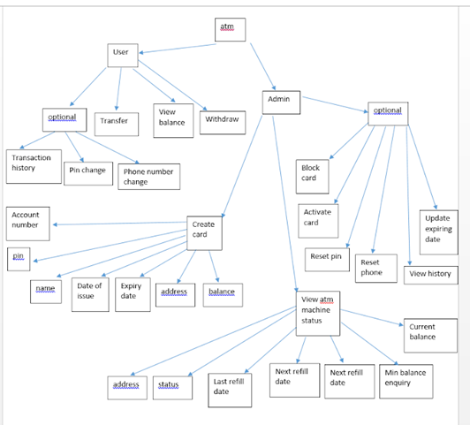

# **3** **Management Plan**

We used trello to keep each other up to date on what has been done and what needs to be done. Each task has priority levels ranging from low to high and in the comments of each task it shows how many hours we think the task will take, and how many hours it actually took when finished. Each task could also be assigned to different people on trello, and they also had set due dates, so we could keep up with our schedule.

We used GitHub for version control and sharing any updated code with team members. Our basic strategy for code base was to have a ‘master’ branch and then three sub branches off of master for each developer. This would allow each developer to experiment and test there code while not messing up the ‘main’ version of the code. Once a developer was done with a section of code, they could merge it with master.

We also used Discord for communication during the project. This allowed everyone to see any conversation that any team members are having. It also allowed a backlog of conversion so that anyone could catch up to any new events that happened in development. We would also use it to share screenshots or documents related to this project.

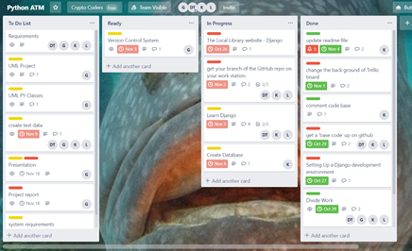

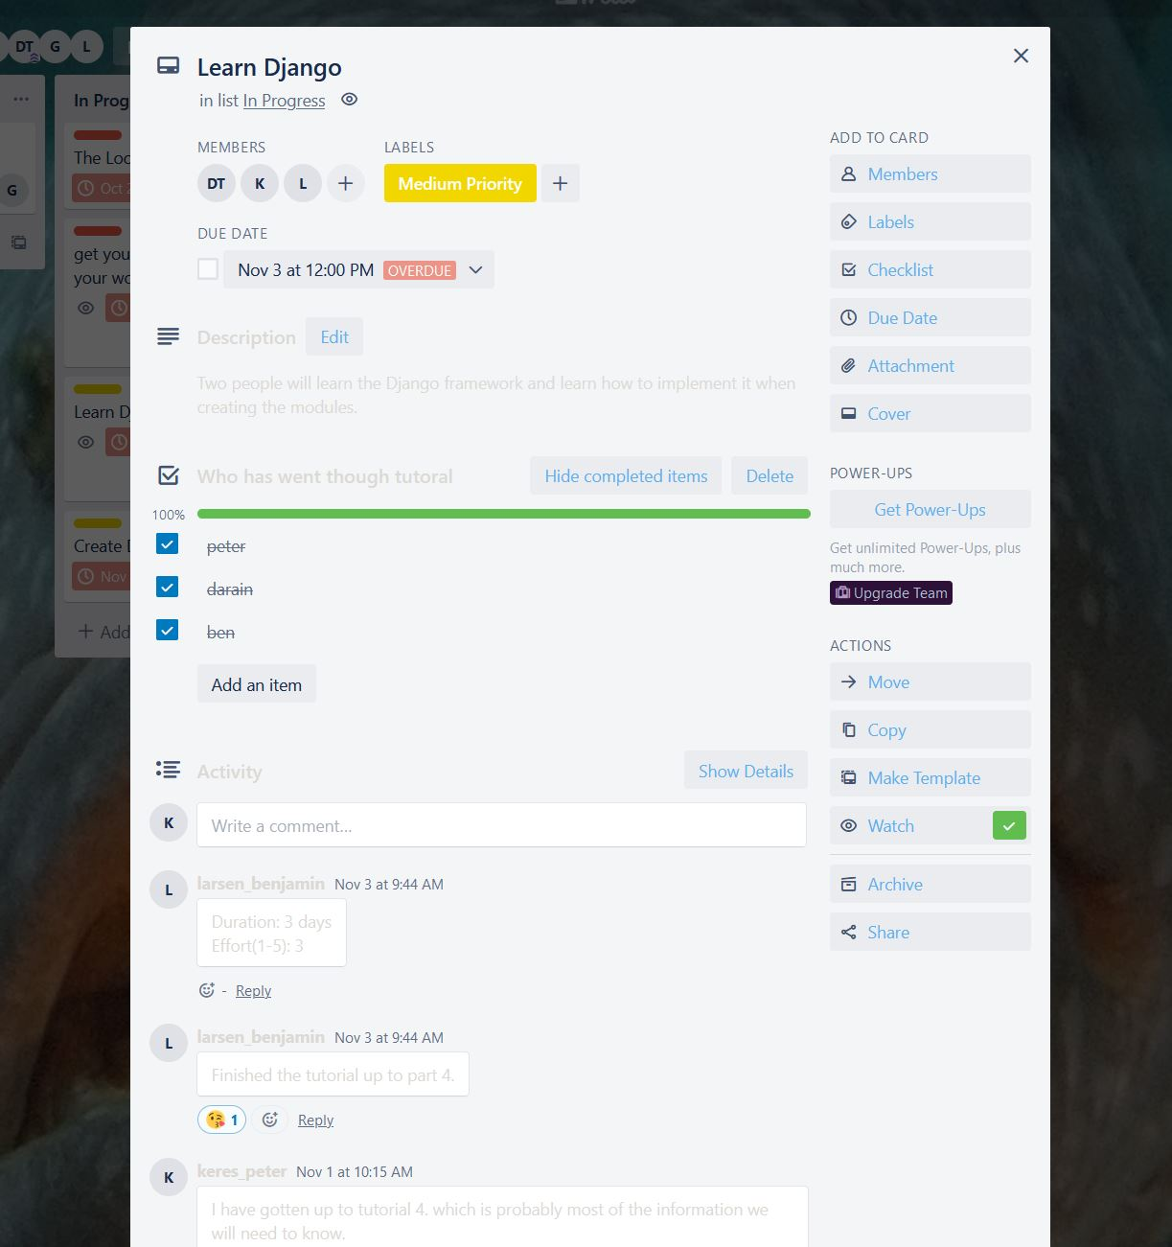

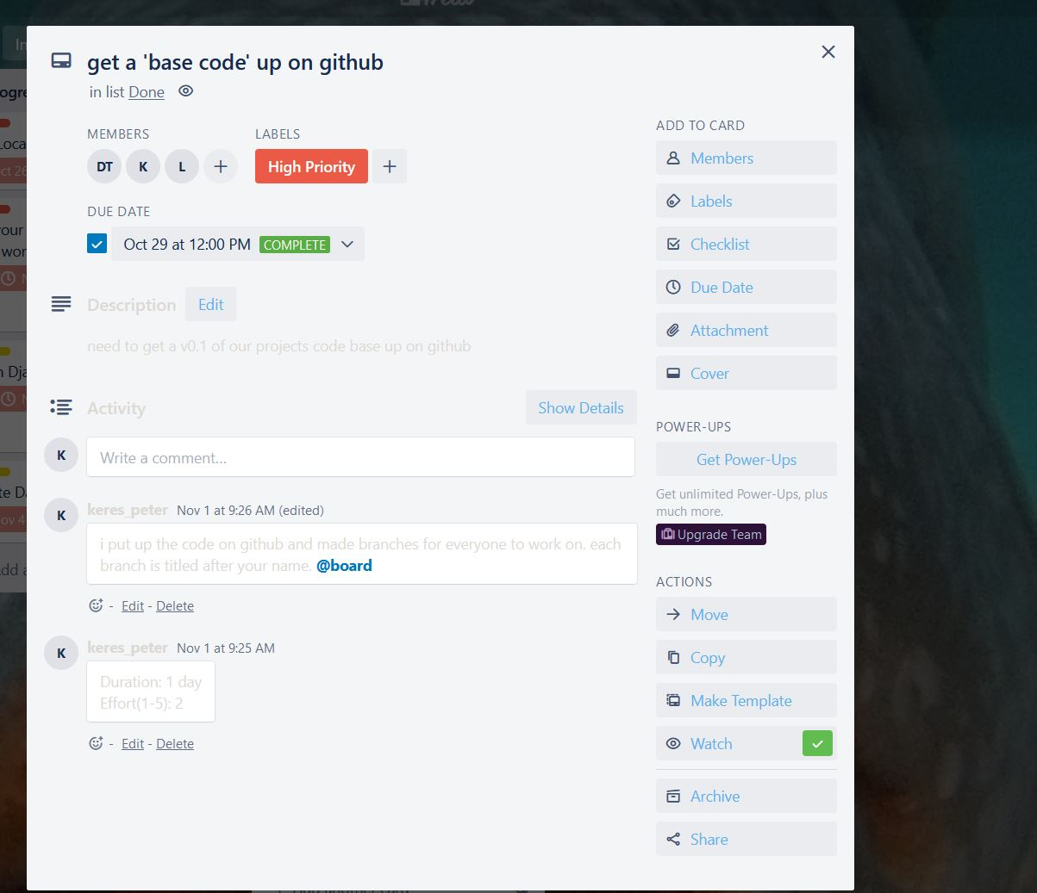

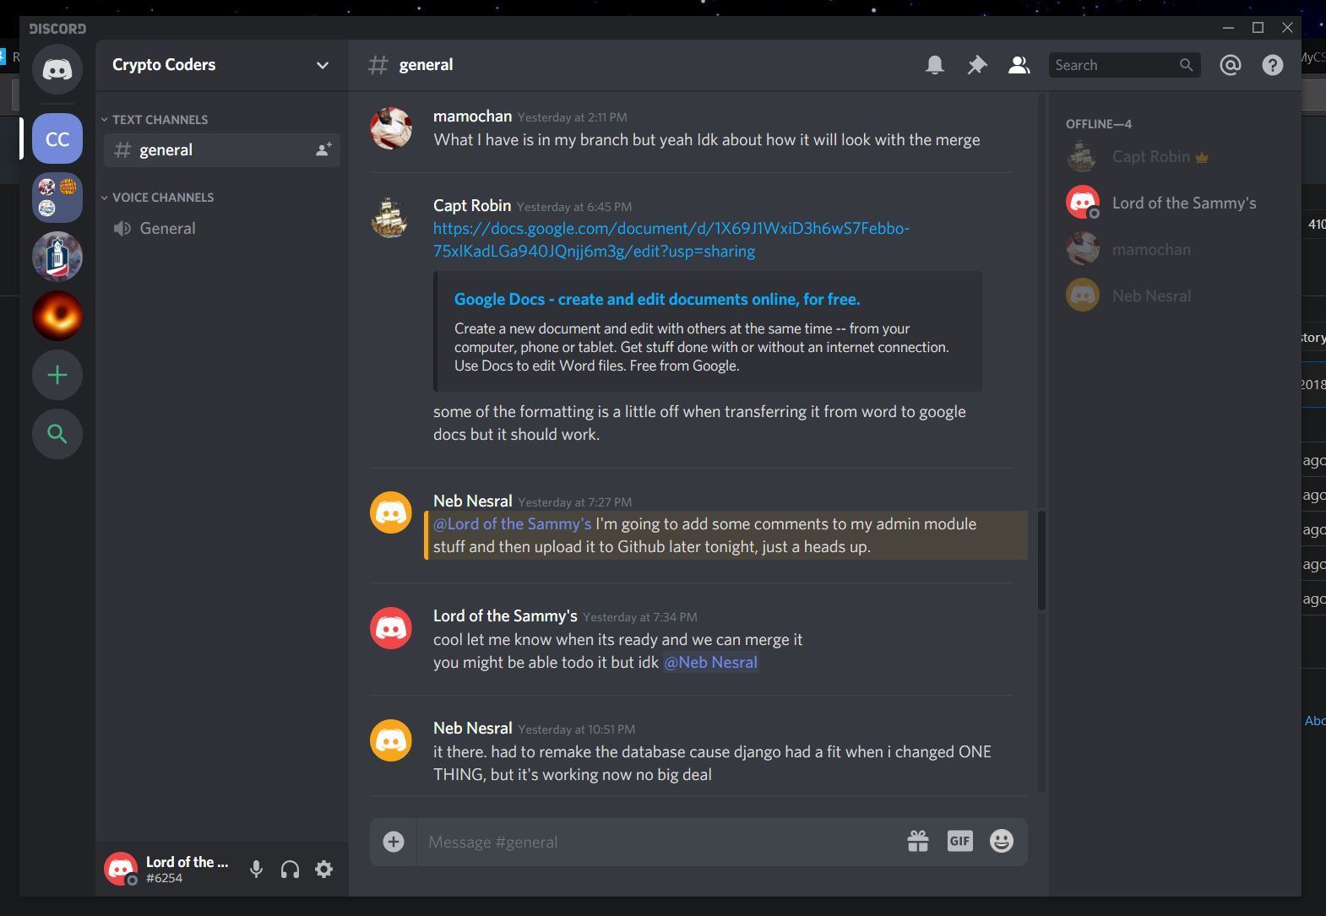

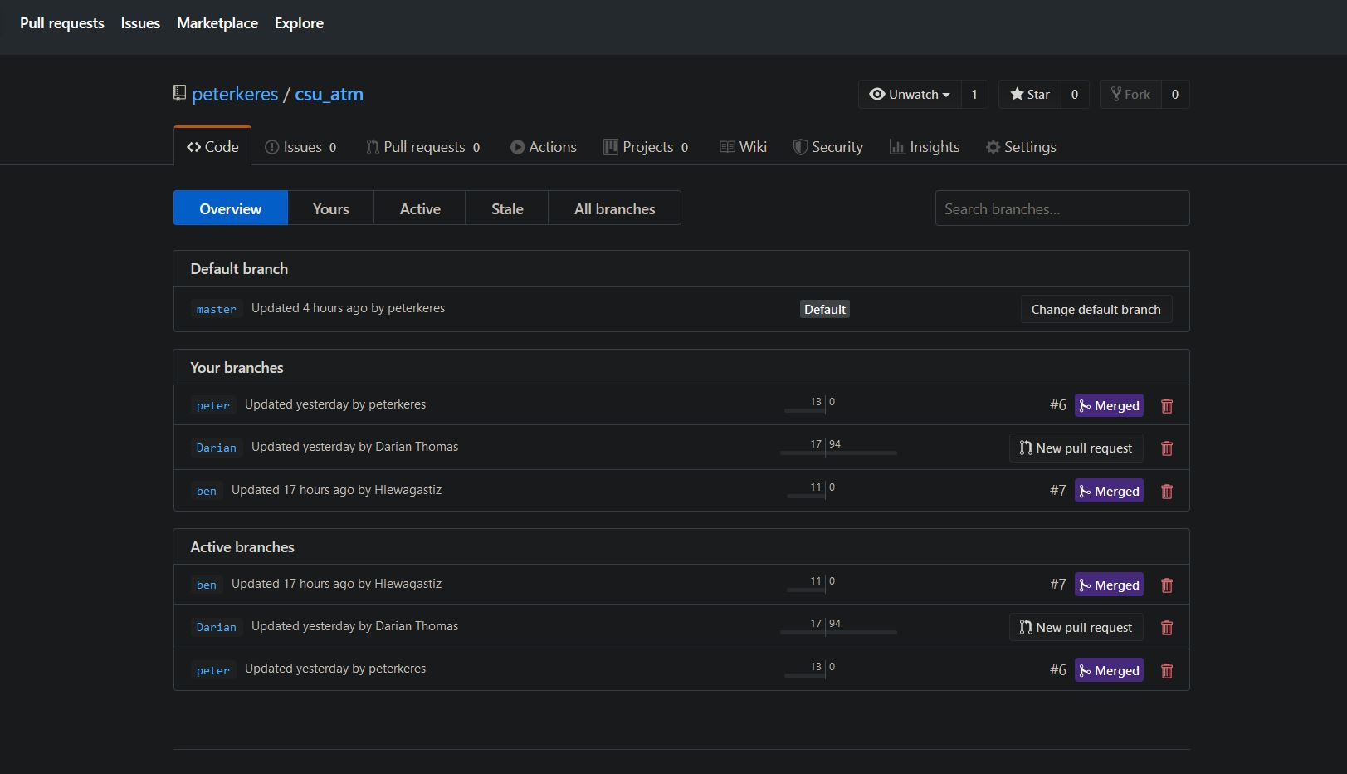

## **3.1** **Development Schedule**

Screenshots of your schedule.

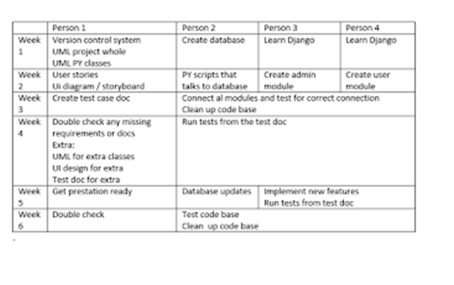

# **4** **Test**

|  |  |  |  |  |
| --- | --- | --- | --- | --- |
| **Objective** | **input** | **Expected output** | **Actual output** | **pass/fail** |
| User Transfer | Transfer 20$ from account with 100$ | Success | Untested | Untested |
| User Transfer | Transfer 20$ from account with 20$ | Success | Untested | Untested |
| User Transfer | Transfer 20$ from account with 10$ | Fail | Untested | Untested |
| User Transfer | Transfer $ to an unknown account | Fail | Untested | Untested |

|  |  |  |  |  |
| --- | --- | --- | --- | --- |
| **Objective** | **input** | **Expected output** | **Actual output** | **pass/fail** |
| User Withdraw | Withdraw 10$ from account with 50$ | Success | Untested | Untested |
| User Withdraw | Withdraw 50$ from account with 50$ | Success | Untested | Untested |
| User Withdraw | Withdraw 100$ from account with 50$ | Fail | Untested | Untested |
| User Withdraw | Withdraw $ is reflected in account balance | Success | Untested | Untested |

|  |  |  |  |  |
| --- | --- | --- | --- | --- |
| **Objective** | **input** | **Expected output** | **Actual output** | **pass/fail** |
| User View | View users name | ‘Jane doe’ | Untested | Untested |
| User View | View phone number | ‘234-567-8901 | Untested | Untested |
| User View | View balance | 200,000 | Untested | Untested |
| User View | Change balance | Error | Untested | Untested |

|  |  |  |  |  |
| --- | --- | --- | --- | --- |
| **Objective** | **input** | **Expected output** | **Actual output** | **pass/fail** |
| Admin View Atm | Atm Status | ‘Active’ | ‘Active’ | Pass |
| Admin View Atm | Atm address | ‘Over by cct’ | ‘Over by cct’ | Pass |
| Admin View Atm | Atm last fill date | 06/22/19 | 06/22/19 | Pass |
| Admin View Atm | Atm next fill date | 09/22/19 | 09/22/19 | Pass |

|  |  |  |  |  |
| --- | --- | --- | --- | --- |
| **Objective** | **input** | **Expected output** | **Actual output** | **pass/fail** |
| Admin New Card | Pin > 4 characters | Error | Error | Pass |
| Admin New Card | Date issued | Today's date | Today's date | Pass |
| Admin New Card | Two factor status | ‘Active’ | ‘Active’ | Pass |
| Admin New Card | Attaching to an unregistered account | Error | Error | Pass |
| Admin New Card | Card number already registered | Error | Error | pass |

|  |  |  |  |  |
| --- | --- | --- | --- | --- |
| **Objective** | **input** | **Expected output** | **Actual output** | **pass/fail** |
| Admin New Account | Add users name to account | ‘John Doe’ saved | ‘John Doe’ save | Pass |
| Admin New Account | Add an account number | ‘112233’ saved | ‘112233’ save | Pass |
| Admin New Account | Add phone number | ‘770 665 8965’ save | ‘770 665 8965’ save | Pass |
| Admin New Account | Add an account number already in use | Error | Error | Pass |
| Admin New Account | Create a starting balance | ‘100.00’ | ‘100.00’ save | pass |

|  |  |  |  |  |
| --- | --- | --- | --- | --- |
| **Objective** | **input** | **Expected output** | **Actual output** | **pass/fail** |
| Admin View Account | View user name | ‘John Doe’ | ‘John Doe’ | Pass |
| Admin View Account | View account number | ‘112233’ | ‘112233’ | Pass |
| Admin View Account | View phone number | ‘770 665 8965’ | ‘770 665 8965’ | Pass |
| Admin View Account | View current balance | ‘100.00’ | ‘100.00’ | Pass |

# **5** **Version Control**

We used github for our version control. We created different branches for each person so that each person could upload their work without uploading to the main branch. This allows us to test our versions and make sure they work before uploading to the main branch.

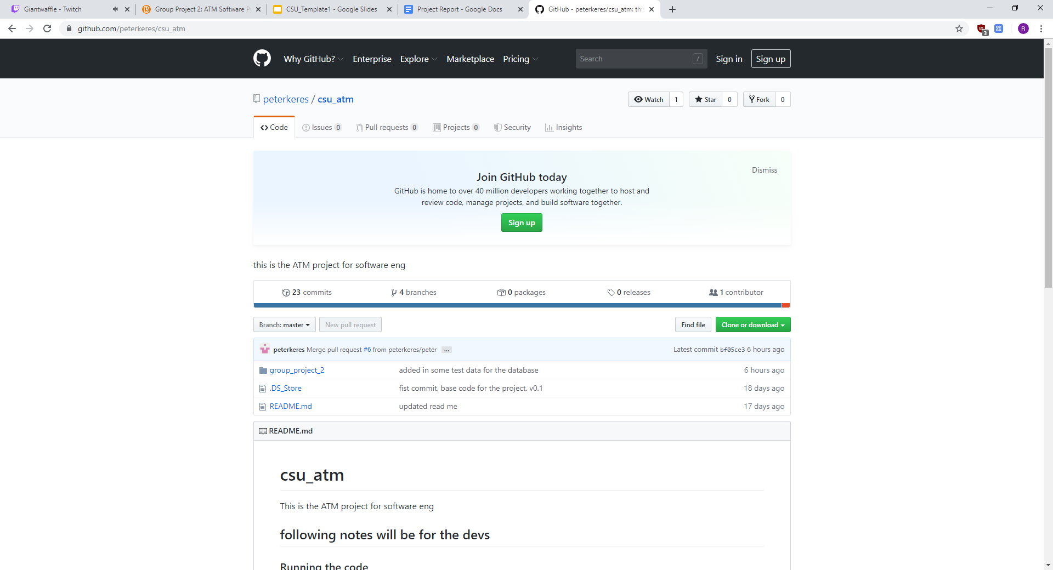

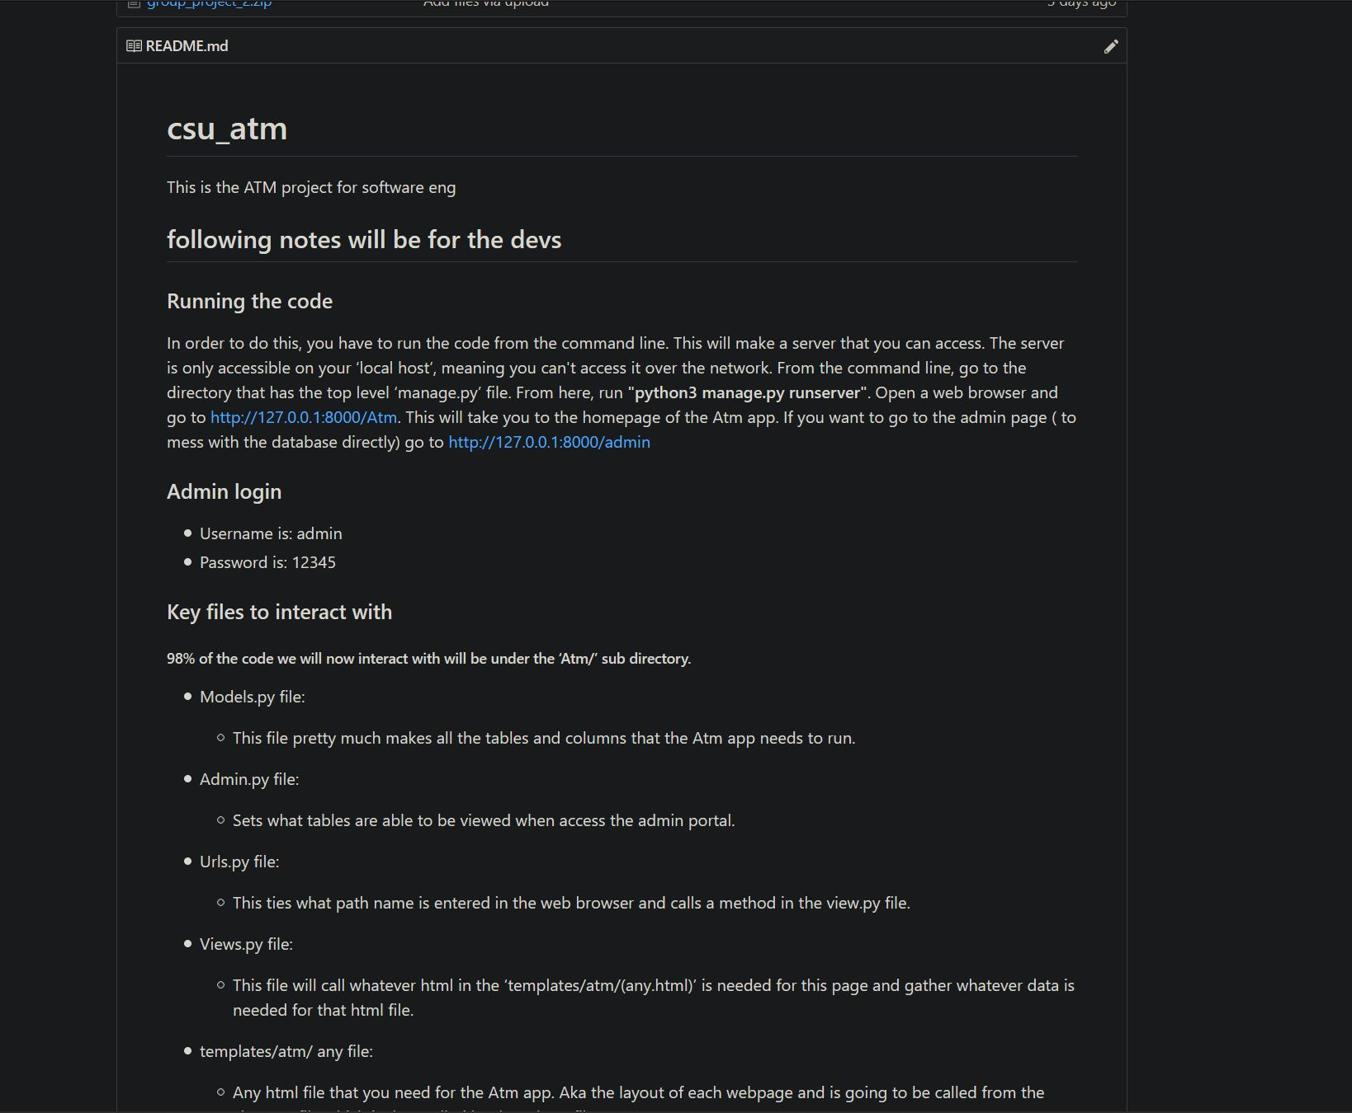

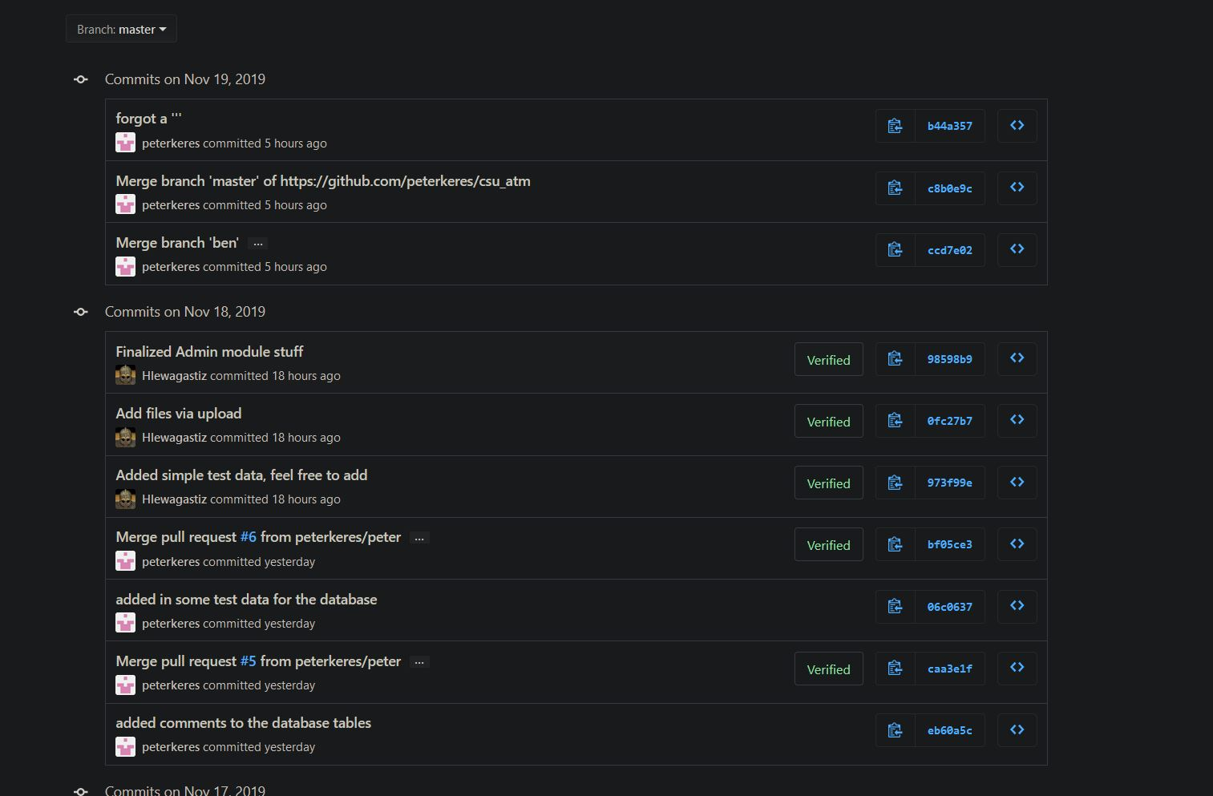

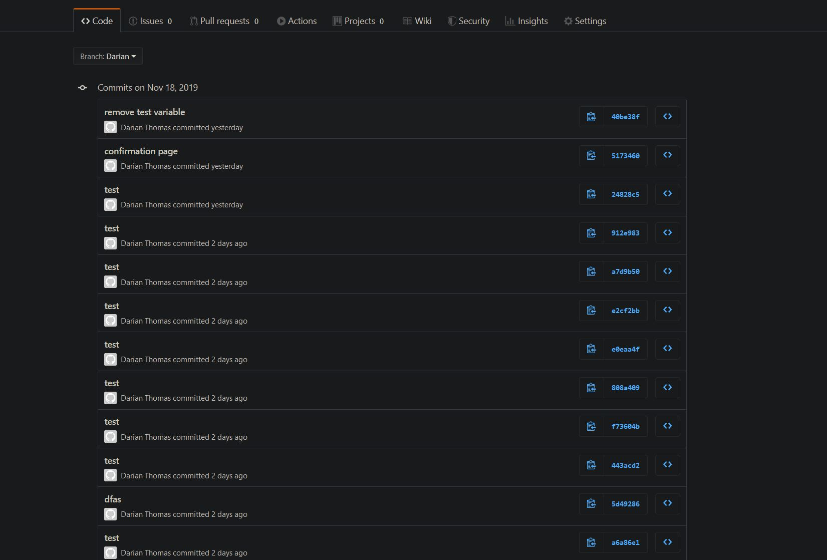

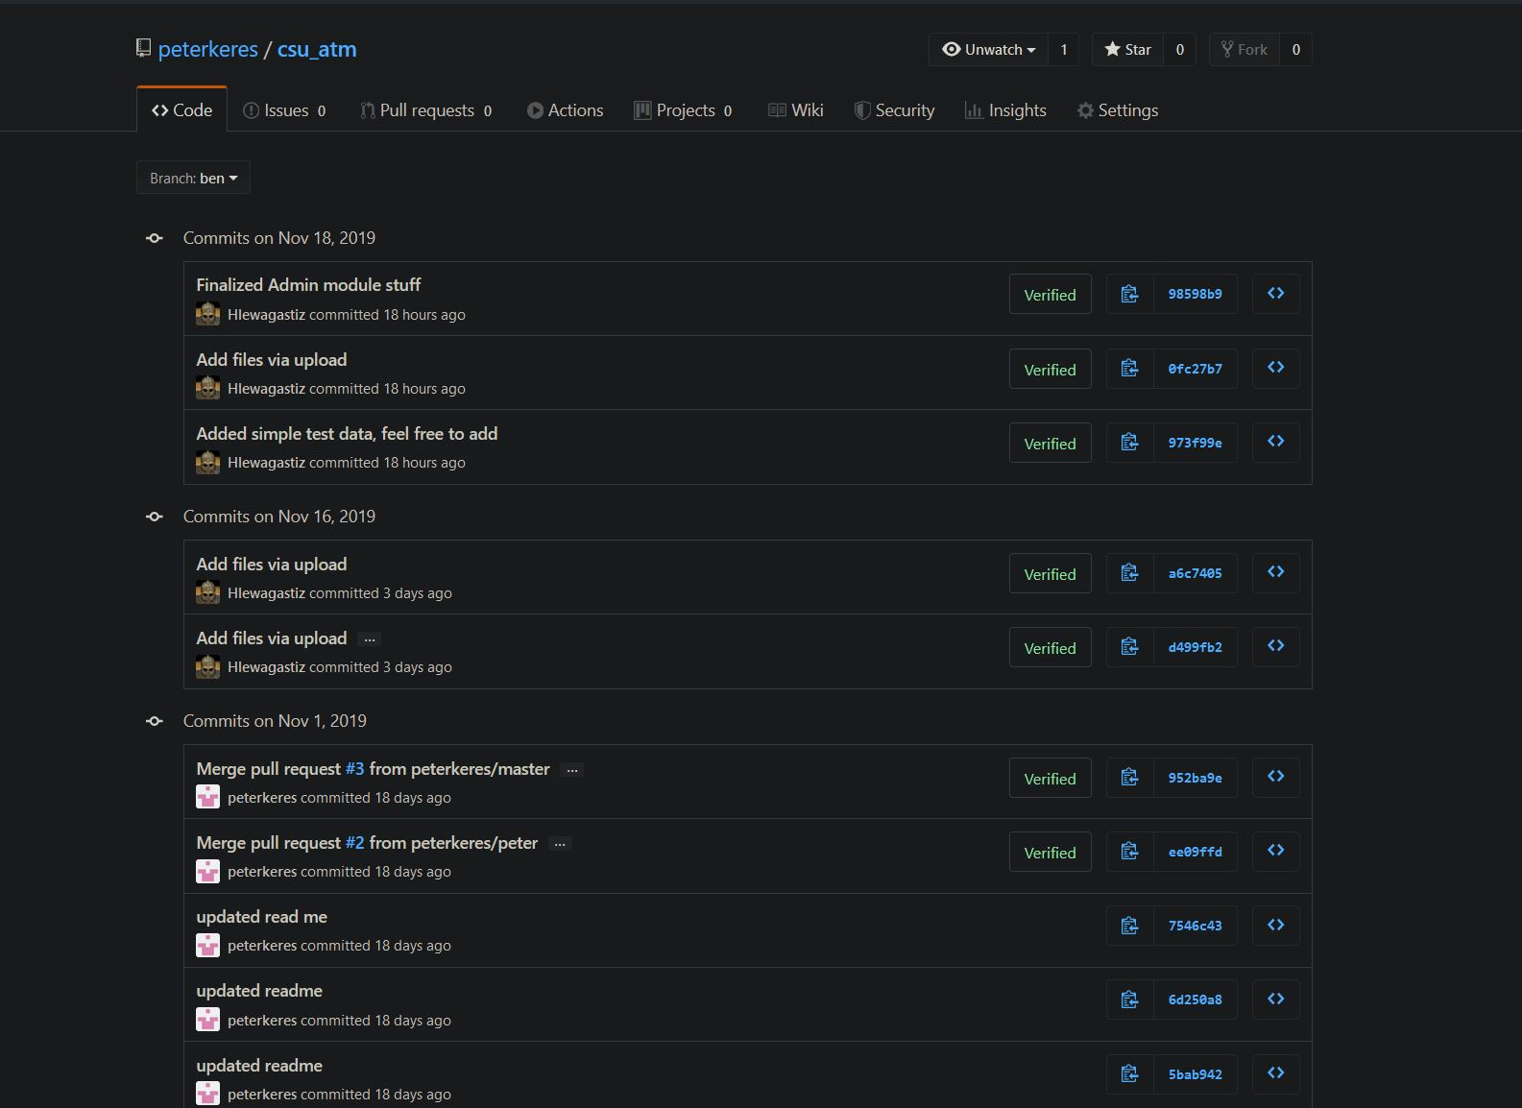

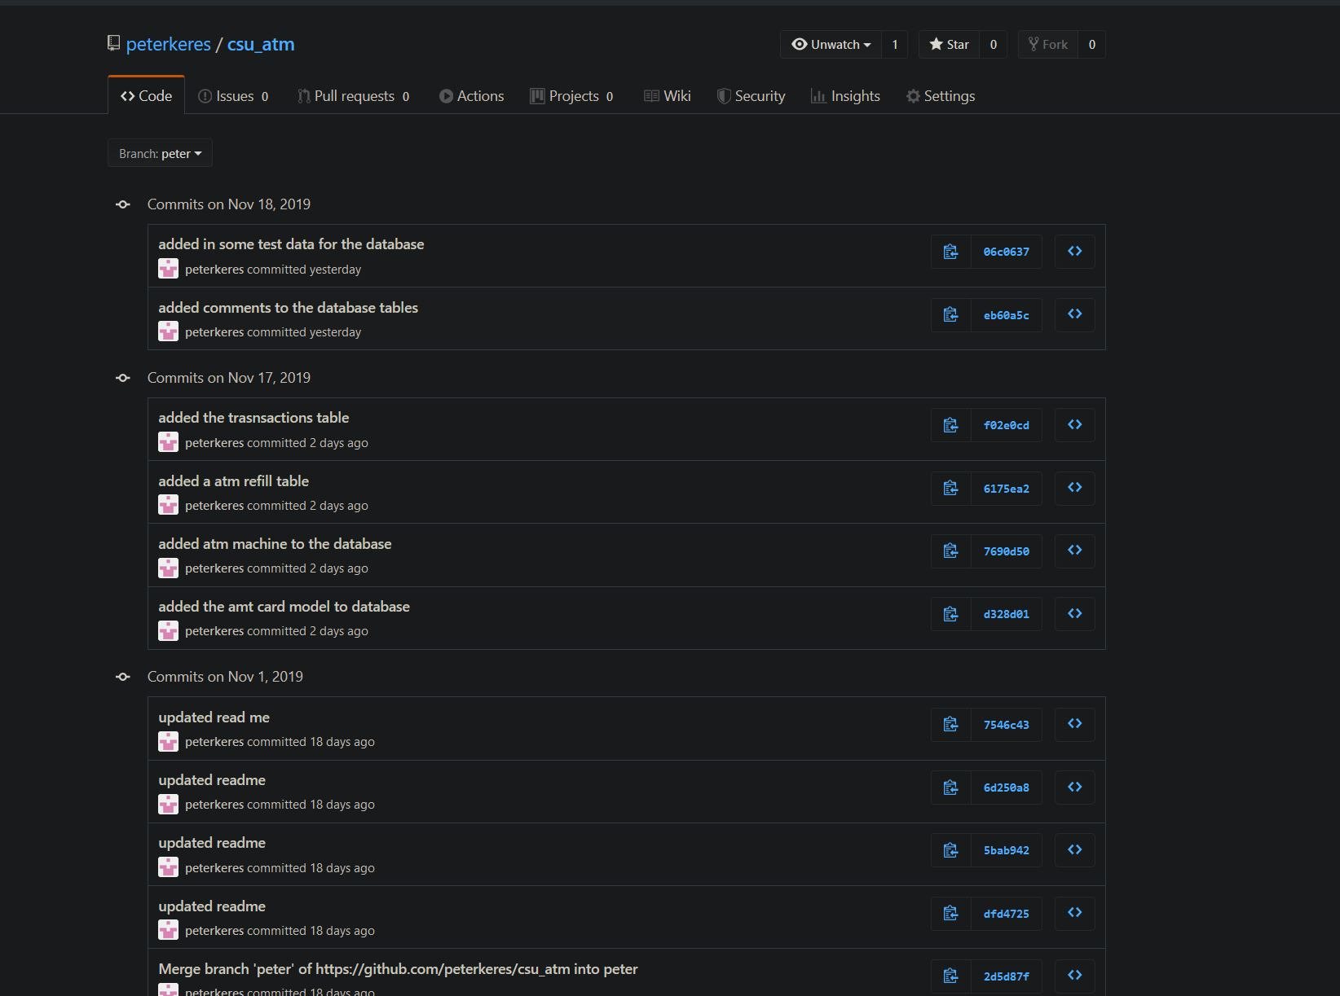

# **6** **Screenshots**

## **6.1** **All the webpages screenshots based on the stories.**

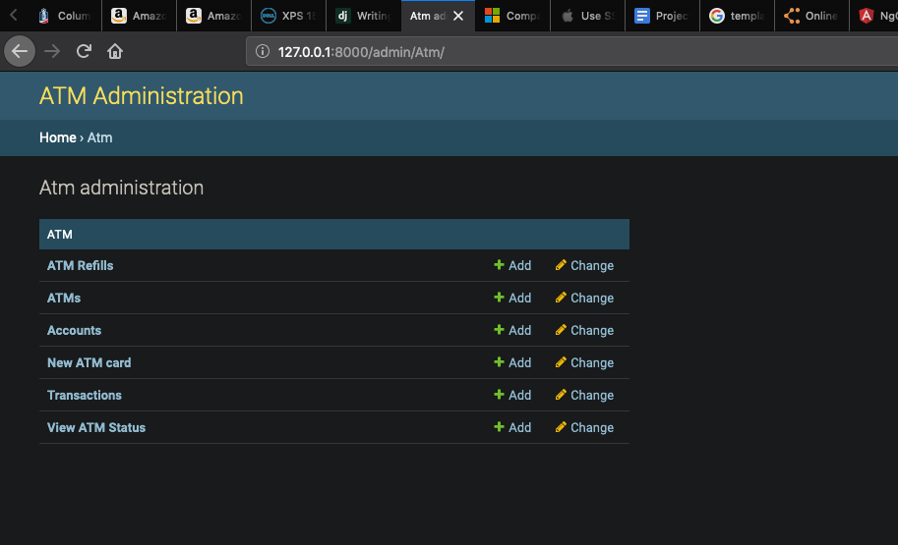

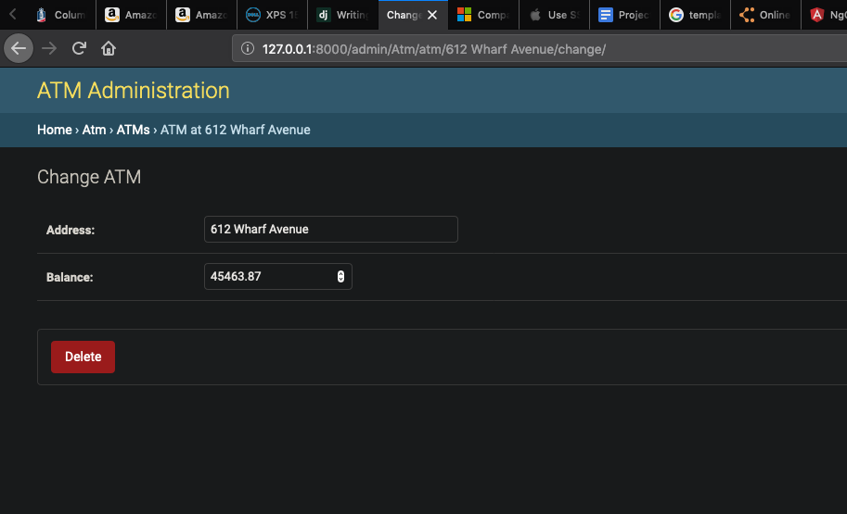

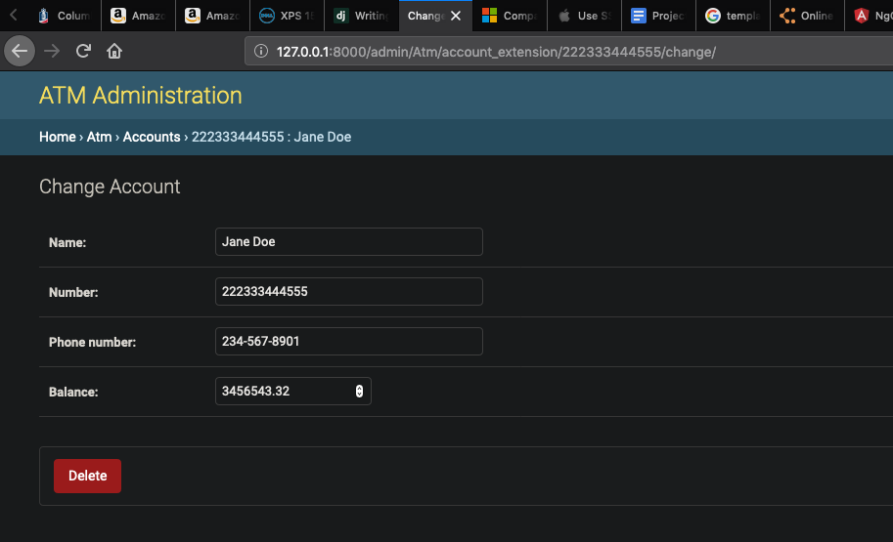

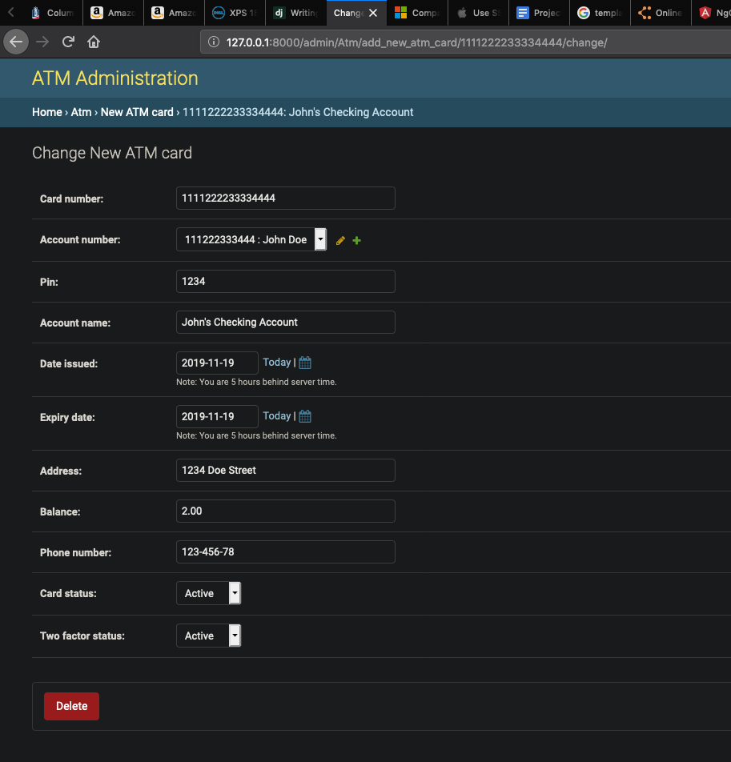

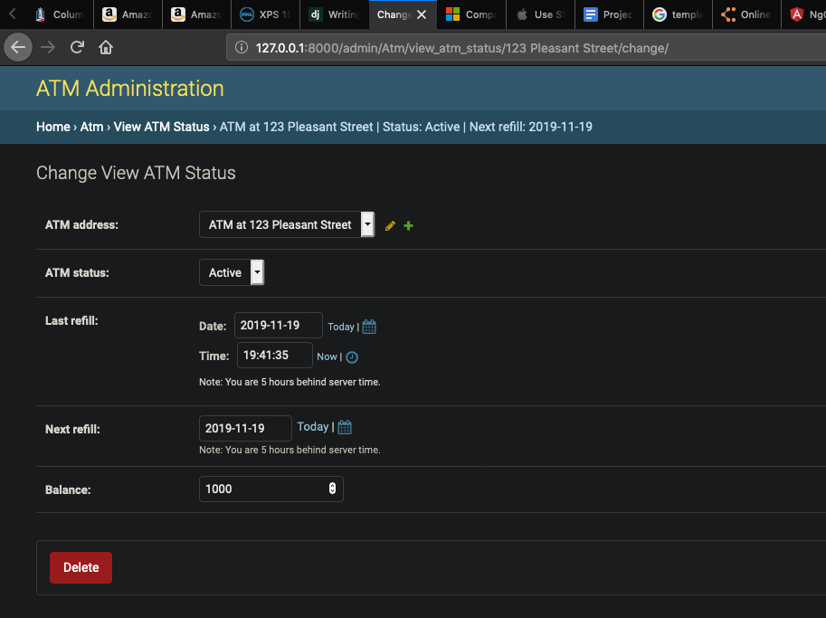

# 

# 

# 

# 

# **7 What is left**

## **7.1 User module**

Currently the user module portion of the project is not implemented in the main branch of our software. We are having problems with pulling items from the database and displaying it in the html files. Once this problem is solved, we can then run the test data that we have laid out to check the stableness of the code. Once it has passed our tests, we can then merge it into our main branch, where we can finally do full tests of the software system.